Q: Add comparing layers in ggplot2

One approach would be to reshape your data frame from wide format to long format using function melt() from library reshape2. In new data frame you will have x1 values, variable that determine from which column data came, and value that contains all original y values.

Now you can plot all data with one ggplot() and geom_line() call and use variable to have for example separate color for each line.

library(reshape2)

df.long<-melt(df,id.vars="x1")

head(df.long)

x1 variable value

1 1 y1 2.0

2 2 y1 5.4

3 3 y1 7.1

4 4 y1 4.6

5 5 y1 5.0

6 1 y2 0.4

ggplot(df.long,aes(x1,value,color=variable))+geom_line()

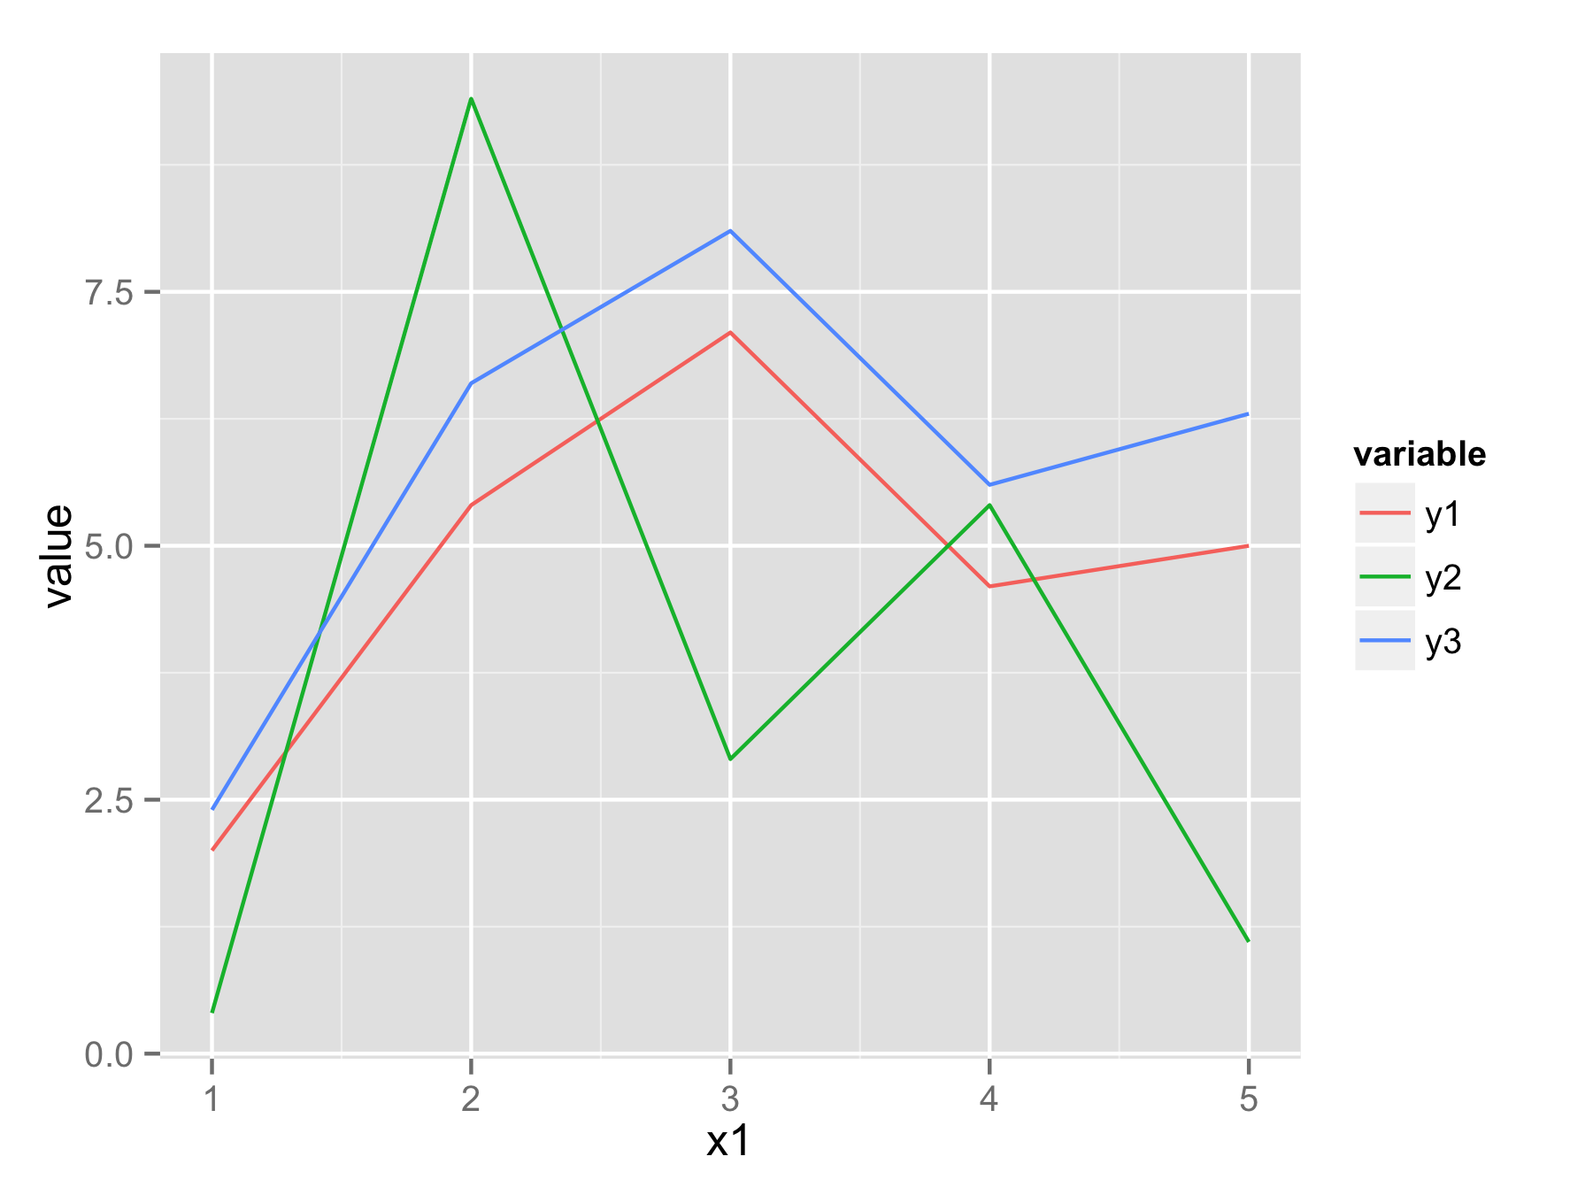

Q: Test if an object contains a certain element

Both the match() (returns the first appearance) and %in% (returns a Boolean) functions are designed for this.

v <- c('a','b','c','e')

'b' %in% v

## returns TRUE

match('b',v)

## returns the first location of 'b', in this case: 2